**Google Analytics Assignment 5**

Author: Karan Ashok

**Date Range: May 1-May 7**

1. From the SEO Dashboard:

a. Percent of Search from Branded Keywords.

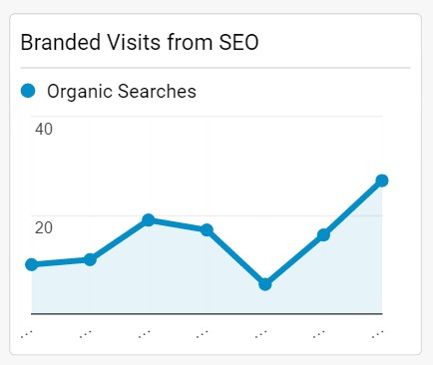

Total Visits:6142

Branded Visits:106

% Search from Branded Keyword=106/6142 =1.73%

b. Percent of Search from Organic Traffic. 45.6%

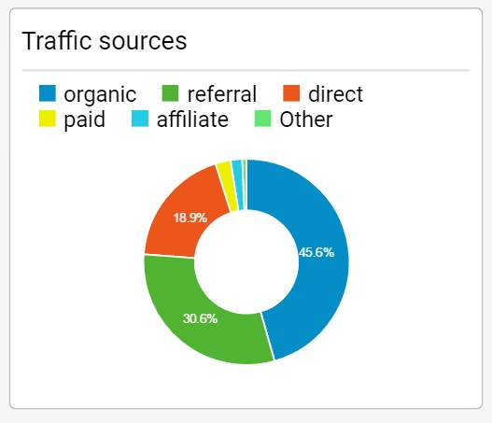

c. Top 5 cities in terms of Organic Search

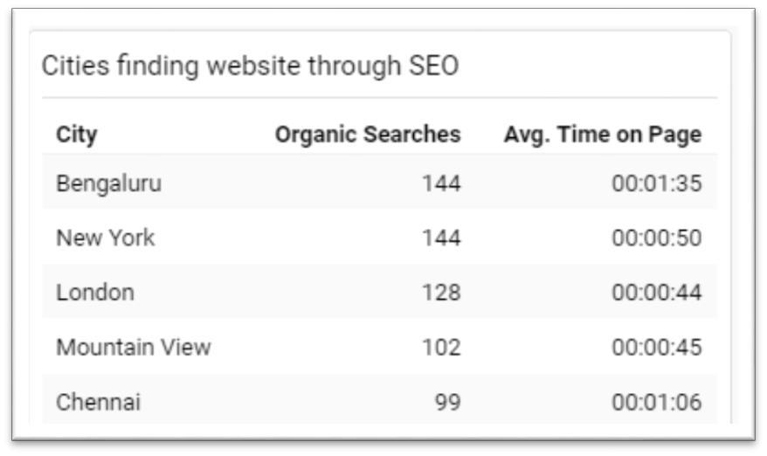

2. From AdWords:

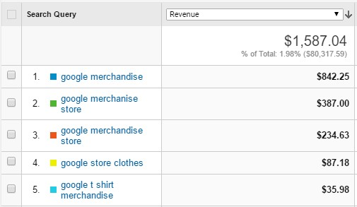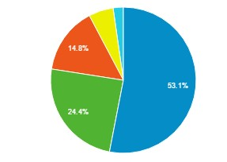

a. The three AdWord search queries that generated revenue

AdWord search queries that generated Maximum Rvenue

1. google merchandise

2. google merchanise store

3. google merchandise store

b. The greatest CPC of the three.

'google merchandise store ' had the greatest CPC of $0.09

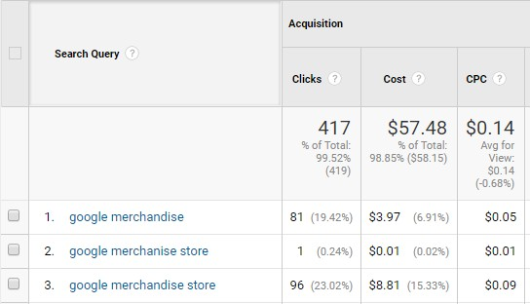

c. The greatest Revenue of the three.

'google merchandise store' had the greatest revenue of $842.25$



d. The greatest ROMI.

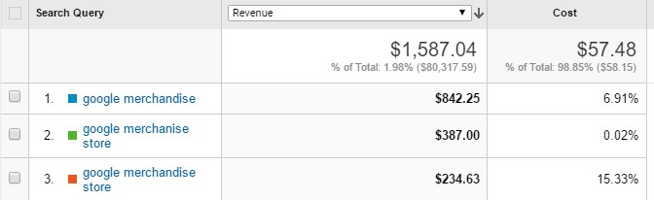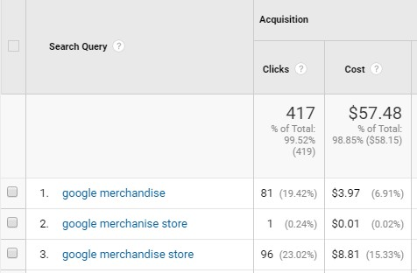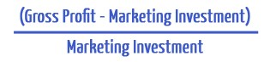

**Assumption: Google has a 40% profit margin**

|  |  |  |  |  |
| --- | --- | --- | --- | --- |
| **Search Query Revenue Cost Profit ROMI** | | | | |
| **google**  **merchandise** | $842.25 | $3.97 | 842.25*.4=$336.9 | (336.9-  3.97)/3.97=83.86 |
| **google merchanise store** | $387.00 | $0.01 | 387*.4=154.8 | (387-  0.01)/.01=38699 |
| **google**  **merchandise store** | $234.63 | $8.81 | 234.63*.4=93.852 | (93.852-  8.81)/8.81=9.65 |

**google merchanise store** has the highest ROMI.

3. First line of the best performing AdWords Advertisement (in terms of revenue). Hint: go to Campaigns and play around. ☺

Best performing AdWords Campaign: **AW-Accessories**

First Line: **Google Merchandise Collection**

